**Gas Leakage Monitoring and Alerting**

**System for Industries**

|  |  |
| --- | --- |
| **PROJECT NAME** | GAS LEAKAGE MONITORING & ALERTING SYSTEM FOR INDUSTRIES |
| **TEAM ID** | **PNT2022TMID09616** |
| **TEAM MEMBERS** | 1.GIRIDHARAN P  2.AKSHAY RAM RB  3.ETHIRAJ M  4.KARTHIKEYAN M |
| **BRANCH** | INFORMATION TECHNOLOGY |

# Abstract:-

Leakage of any kind of gas has been a concern in recent years, whether it is in a residential setting, a business, a cafe, or a canteen. In this paper development of an IoT based gas wastage monitoring, leakage detecting and alerting system is proposed. This paper elaborates design such an intelligent system that will help save gas and smartly prevent accidents. The system needs to be integrated with the cooker. The technology includes ultrasonic sensors that determine if the cooker is being utilized for cooking purposes or not. If it is discovered that the cooker is not in use, the system uses an automatic switching off mechanism to cut off the gas supply. The moment gas leakage will probably be recognized, users will be informed via SMS through GSM, and so that user can solve the issue as soon as possible. The system will monitor flame and fire through flame sensor. When a fire is detected, the buzzer begins to sound. Aside from that, the system also has a cloud storage capability. The usage of gas for each user each day may be tracked with the aid of this cloud storage solution. At the end of the day, this procedure will assist in detecting per user natural gas usage. The system has been tested and it is able to monitor gas wastage, leakage and send a SMS to the user. The resulting performance indicated its effectiveness toward saving a significant portion of the wasted gas in domestic.

**Introduction :-**

Now a days the home safety detection system plays the important role for the security of people. Since all the people from the home goes to work on daily bases, it makes impossible to check on the appliances available at home specially LPG gas cylinder, wired circuits, Etc. Since last three years there is a tremendous hike in the demands of liquefied petroleum gas (LPG) and natural gas. To meet this access amount of demand for energy and replace oil or coal due to their environmental disadvantage, LPG and natural gas are preferred. These gases are mostly used on large scale in industry, heating, home appliances and motor fuel. So as to track this leakage gas, the system includes MQ6 gas sensor. This sensor senses the amount of leak gas present in the surrounding atmosphere. Through this, explosion or getting affected by the leakage of gas could be avoided.

# Objective :-

The design of a sensor-based automatic gas leakage detector with an alert and control system has been proposed. This is an affordable, less power using, lightweight, portable, safe, user friendly, efficient, multi featured and simple system device for detecting gas. Gas leakage detection will not only provide us with significance in the health department but it will also lead to raise our economy, because when gas leaks it not only contaminates the atmosphere, but also wastage of gases will hurt our economy. The need for ensuring safety in workplaces is expected to be the key driving force for the market over the coming years.

# Problem Formulation:-

Gas leakage is nothing but the leak of any gaseous molecule from a stove, or a pipeline, or cylinder etc. This can occur either purposefully or even unintendedly. As we are aware that these kinds of leaks are dangerous to our health, and when it becomes explosive it could cause great danger to the people, home, workplace, industry and the environment.

Few of the major incidents that took place due to gas leakage include the Bhopal Disaster and the Vizag Gas leak. The Bhopal disaster is known to be the worst industrial accident ever. Approximately 45 tons of Methyl Isocyanate was leaked from this insecticide plant. Methyl Isocyanate is an organic compound and a chemical that could come from the carbamate pesticides. This colorless, poisonous and flammable liquid is something that human beings have to be away from.

Vizag Gas leak was a resultant of the escape of styrene that were unattended for a long period. This colorless oily liquid can spread in fumes. So, a detector must be made in such a way that could detect any kind of gas, fume, leak, smoke etc. However harmful and dangerous it can be, the detector could be attached with certain parameters that could help to prevent the issue.

# List of Components :-

|  |  |  |  |
| --- | --- | --- | --- |
| **S. No** | **Name of the Component** |  | **Quantity** |
| 1. | Arduino UNO R3 | 1 |  |
| 2. | Breadboard | 1 |  |
| 3. | LED | 2 |  |
| 4. | Resistor | 5 |  |
| 5. | Piezo | 1 |  |
| 6. | Gas Sensor | 1 |  |
| 7. | LCD 16*2 | 1 |  |

## Arduino UNO R3 :-

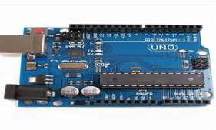

Arduino Uno R3 is one kind of ATmega328P based microcontroller board. It includes the whole thing required to hold up the microcontroller; just attach it to a PC with the help of a USB cable, and give the supply using AC-DC adapter or a battery to get started. The term Uno means “one” in the language of “Italian” and was selected for marking the release of Arduino’s IDE 1.0 software. The R3 Arduino Uno is the 3rd as well as most recent modification of the Arduino Uno. Arduino board and IDE software are the reference versions of Arduino and currently progressed to new releases. The Uno-board is the primary in a sequence of USB-Arduino Board, & the reference model designed for the Arduino platform.

## Breadboard :-

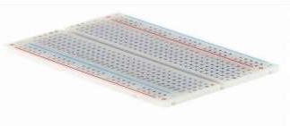

A breadboard is a widely used tool to design and test circuit. You do not need to solder wires and components to make a circuit while using a bread board. It is easier to mount components & reuse them. Since, components are not soldered you can change your circuit design at any point without any hassle. It consist of an array of conductive metal clips encased in a box made of white ABS plastic, where each clip is insulated with another clips. There are a number of holes on the plastic box, arranged in a particular fashion. A typical bread board layout consists of two types of region also called strips. Bus strips and socket strips. Bus strips are usually used to provide power supply to the circuit. It consists of two columns, one for power voltage and other for ground. Socket strips are used to hold most of the components in a circuit. Generally it consists of two sections each with 5 rows and 64 columns. Every column is electrically connected from inside.

### LED :-

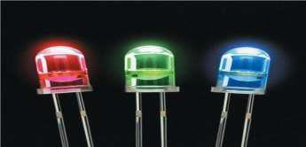

LED (Light Emitting Diode) is an optoelectronic device which works on the principle of electro-luminance. Electro-luminance is the property of the material to convert electrical energy into light energy and later it radiates this light energy. In the same way, the semiconductor in LED emits light under the influence of electric field. The symbol of LED is formed by merging the symbol of P-N Junction diode and outward arrows. These outward arrows symbolise the light radiated by the light emitting diode.

### Resistor :-

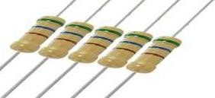

A passive electrical component with two terminals that are used for either limiting or regulating the flow of electric current in electrical circuits.

### Piezo :-

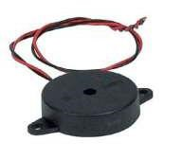

A piezo is a device that generates a voltage when force is applied or becomes deformed when voltage is supplied.

#### Gas Sensor :-

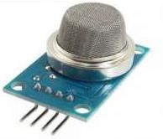

A gas sensor is a device which detects the presence or concentration of gases in the atmosphere. Based on the concentration of the gas the sensor produces a corresponding potential difference by changing the resistance of the material inside the sensor, which can be measured as output voltage. Based on this voltage value the type and concentration of the gas can be estimated.

#### LCD 16*2 :-

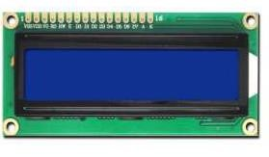

16×2 LCD is one kind of electronic device used to display the message and data. The term LCD full form is Liquid Crystal Display. The display is named 16×2 LCD because it has 16 Columns and 2 Rows. it can be displayed (16×2=32) 32 characters in total and each character will be made of 5×8 Pixel Dots. These displays are mainly based on multi-segment light emitting diodes. There are a lot of combinations of display available in the market like 8×1, 8×2, 10×2, 16×1, etc. but the 16×2 LCD is widely used. These LCD modules are low cost, and programmer-friendly, therefore, is used in various DIY circuits, devices, and embedded projects.

# Proposed Method :-

Arduino UNO (Atmega-328) is the main unit of the system which performs the following tasks. A signal conditioning of the Arduino UNO is done by output signal of the sensor, provided input to Arduino. The detection results displayed on LCD. Indicates the people of danger in work place, factory, home. Buzzer activity with beep(siren) sound is made. Also send alert SMS to the in charge of the plant whose number is saved in SIM card by using GSM modem. The SMS received depends upon the leak of gas in the detection area of the sensor.

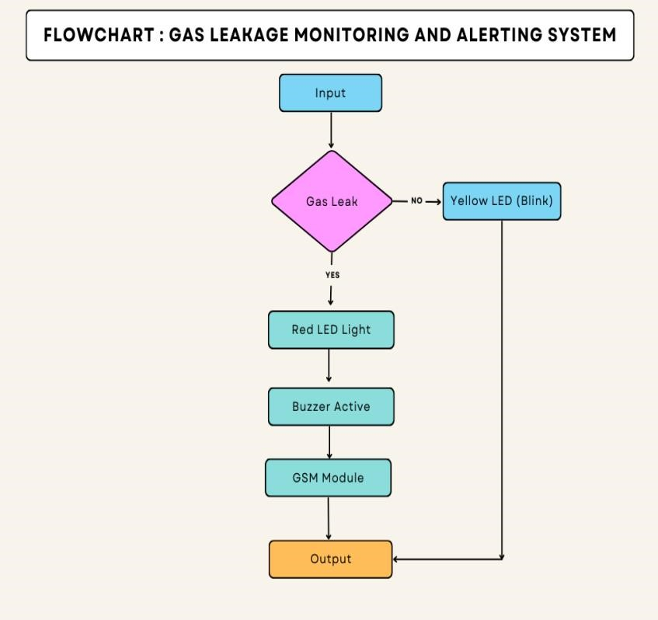

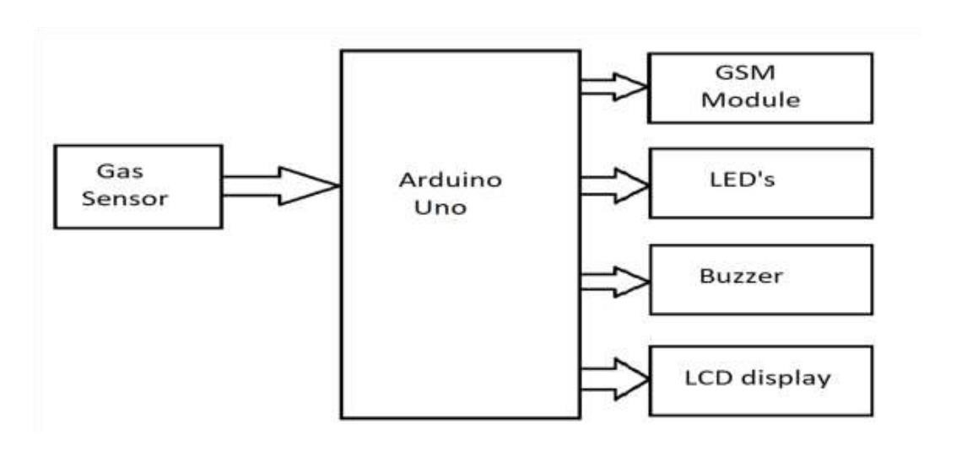

# Circuit Diagram :-

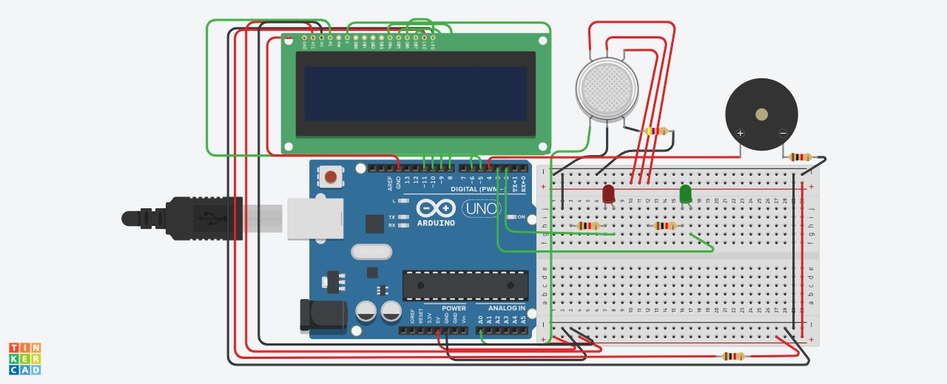

**Solution Statement :-**

The system can be taken as a small attempt in connecting the existing primary gas detection methods to a mobile platform integrated with IoT platforms. The gases are sensed in an area of 1m radius of the rover and the sensor output datas are continuously transferred to the local server. The accuracy of sensors are not upto the mark thus stray gases are also detected which creates an amount of error in the outputs of the sensors, especially in case of methane. Further the availability and storage of toxic gases like hydrogen sulphide also creates problems for testing the assembled hardware. As the system operates outside the pipeline, the complication of system maintenance and material selection of the system in case of corrosive gases is reduced. Thus the system at this stage can only be used as a primary indicator of leakage inside a plant.

# ConclusiOn :-

After this project performance, can conclude that detection of the LPG gas leakage is incredible in the project system. Applicable usefully in the industrial and domestic purpose. In danger situations we are able to save the life by using this system. An alert is indicated by the GSM module. A sensor node senses gas like CO2, oxygen, propane. The estimated range of transmission and consumption of power is obtained. The simple procedures and Arduino UNO Micro controller area used to build the sensor.